|  |  |
| --- | --- |
| **EXP NO. 01**  **DATE:** 24.01.2025 | **Univariate, Bivariate and Multivariate Regression** |

# AIM:

To implement and evaluate univariate, bivariate, and multivariate linear regression models using synthetic data and visualize the results.

# ALGORITHM:

**Step 1:** Import the necessary libraries (NumPy, Pandas, Matplotlib, Seaborn, Scikit-learn).

**Step 2:** Set a random seed for reproducibility.

**Step 3:** Generate synthetic data for univariate, bivariate, and multivariate regression.

**Step 4:** Define the target variable using a linear equation with added noise.

**Step 5:** Fit a Linear Regression model to the data.

**Step 6:** Predict the output using the trained model.

**Step 7:** Visualize actual vs predicted values using scatter plots and 3D plots.

**Step 8:** Calculate and display performance metrics (MSE and R² Score).

**Step 9:** End the program.

# SOURCE CODE:

import numpy as np import pandas as pd

import matplotlib.pyplot as plt import seaborn as sns

from sklearn.linear_model import LinearRegression

from sklearn.metrics import mean_squared_error, r2_score

from mpl_toolkits.mplot3d import Axes3D

# Set random seed np.random.seed(42)

# --- 1. UNIVARIATE REGRESSION ---

# Simulate data

X_uni = np.random.rand(100, 1) * 10

y_uni = 3 * X_uni.squeeze() + 7 + np.random.randn(100) * 2

# Fit model

model_uni = LinearRegression().fit(X_uni, y_uni) y_uni_pred = model_uni.predict(X_uni)

# Plot plt.figure(figsize=(6,4))

plt.scatter(X_uni, y_uni, label="Actual", color="blue") plt.plot(X_uni, y_uni_pred, label="Predicted", color="red") plt.title("Univariate Regression")

plt.xlabel("X")

plt.ylabel("y") plt.legend() plt.show()

# Metrics

print("Univariate Regression:")

print("MSE:", mean_squared_error(y_uni, y_uni_pred)) print("R² Score:", r2_score(y_uni, y_uni_pred))

print()

# --- 2. BIVARIATE REGRESSION ---

# Simulate data

X1 = np.random.rand(100, 1) * 10

X2 = np.random.rand(100, 1) * 5 X_bi = np.hstack([X1, X2])

y_bi = 2 * X1.squeeze() + 4 * X2.squeeze() + 5 + np.random.randn(100) * 2

# Fit model

model_bi = LinearRegression().fit(X_bi, y_bi) y_bi_pred = model_bi.predict(X_bi)

# 3D plot

fig = plt.figure(figsize=(7,5))

ax = fig.add_subplot(111, projection='3d') ax.scatter(X1, X2, y_bi, c='blue', label='Actual')

ax.scatter(X1, X2, y_bi_pred, c='red', label='Predicted', alpha=0.5) ax.set_xlabel("X1")

ax.set_ylabel("X2") ax.set_zlabel("y") ax.set_title("Bivariate Regression") plt.legend()

plt.show()

# Metrics

print("Bivariate Regression:")

print("MSE:", mean_squared_error(y_bi, y_bi_pred)) print("R² Score:", r2_score(y_bi, y_bi_pred))

print()

# --- 3. MULTIVARIATE REGRESSION ---

# Simulate data

X_multi = np.random.rand(100, 5) coeffs = np.array([2, -1, 3, 0.5, 4])

y_multi = X_multi @ coeffs + 10 + np.random.randn(100) * 2

# Fit model

model_multi = LinearRegression().fit(X_multi, y_multi) y_multi_pred = model_multi.predict(X_multi)

# Plot residuals plt.figure(figsize=(6,4))

sns.histplot(y_multi - y_multi_pred, kde=True) plt.title("Residuals - Multivariate Regression") plt.xlabel("Residuals")

plt.show()

# Metrics

print("Multivariate Regression:")

print("MSE:", mean_squared_error(y_multi, y_multi_pred)) print("R² Score:", r2_score(y_multi, y_multi_pred))

print()

# OUTPUT:

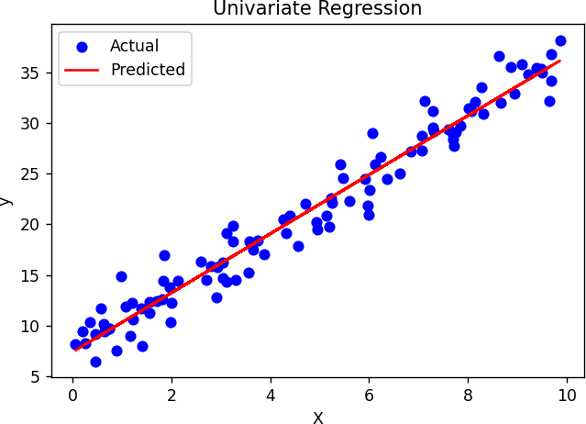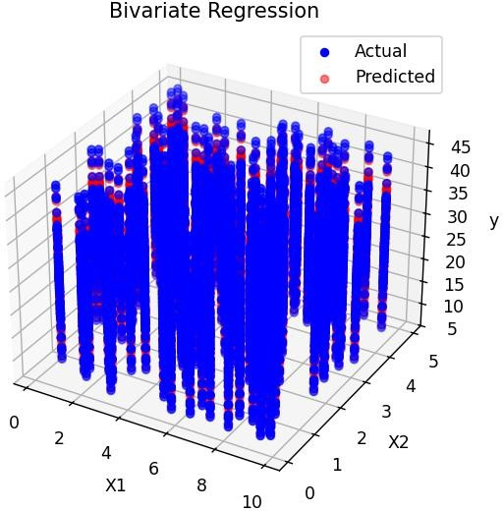

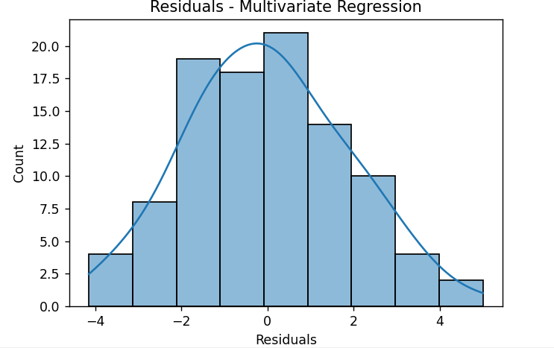

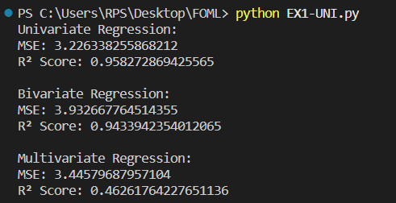

**RESULT:**

The univariate, bivariate, and multivariate linear regression models were successfully implemented, and the predicted outputs closely matched the actual values with high R² scores and low mean squared errors, indicating good model performance.

|  |  |
| --- | --- |
| **EXP NO. 02**  **DATE:** 31.01.2025 | **Simple Linear Regression using Least Square Method** |

# AIM:

To implement simple linear regression using the Least Squares Method and evaluate the model performance using Mean Squared Error and R² Score.

# ALGORITHM:

**Step 1:** Import the required libraries (NumPy and Matplotlib).

**Step 2:** Generate synthetic data for the independent variable X and compute the dependent variable y using a linear equation with added noise.

**Step 3:** Calculate the mean of X and y.

**Step 4:** Compute the slope and intercept using the Least Squares formula.

**Step 5:** Predict the output values y_pred using the regression equation.

**Step 6:** Plot the actual data points and the regression line.

**Step 7:** Calculate performance metrics – Mean Squared Error (MSE) and R² Score.

**Step 8:** Display the slope, intercept, MSE, and R² Score.

**Step 9:** End the program.

**SORCE CODE:**

import numpy as np

import matplotlib.pyplot as plt

# 1. Simulate data (y = 2x + 5 + noise) np.random.seed(0)

X = np.random.rand(100) * 10 noise = np.random.randn(100) y = 2 * X + 5 + noise

# 2. Least Squares Calculation x_mean = np.mean(X) y_mean = np.mean(y)

numerator = np.sum((X - x_mean) * (y - y_mean)) denominator = np.sum((X - x_mean) ** 2)

slope = numerator / denominator intercept = y_mean - slope * x_mean

# 3. Predictions

y_pred = slope * X + intercept

# 4. Plot plt.figure(figsize=(6,4))

plt.scatter(X, y, label="Actual", color="blue")

plt.plot(X, y_pred, color="red", label="Prediction (Line of Best Fit)") plt.title("Simple Linear Regression - Least Squares")

plt.xlabel("X")

plt.ylabel("y") plt.legend() plt.show()

# 5. Performance Metrics

mse = np.mean((y - y_pred) ** 2)

r2 = 1 - (np.sum((y - y_pred)**2) / np.sum((y - np.mean(y))**2))

# 6. Output

print(f"Intercept: {intercept:.2f}") print(f"Slope: {slope:.2f}")

print(f"Mean Squared Error (MSE): {mse:.2f}") print(f"R² Score: {r2:.2f}")

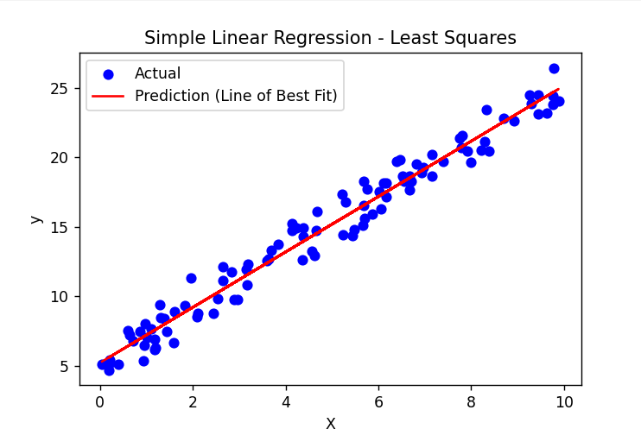**OUTPUT:**

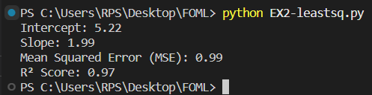

**RESULT:**

Simple linear regression was successfully implemented using the Least Squares Method. The regression line closely fits the data, and the model shows good performance with a low Mean Squared Error and a high R² Score.

|  |  |
| --- | --- |
| **EXP NO. 03**  **DATE:** 07.02.2025 | **Logistic Regression** |

# AIM:

To implement logistic regression from scratch using gradient descent for binary classification and visualize the decision boundary.

# ALGORITHM:

**Step 1:** Generate synthetic 2D data for two classes.

**Step 2:** Add a bias term to the feature matrix.

**Step 3:** Define the sigmoid activation function.

**Step 4:** Define the binary cross-entropy loss function.

**Step 5:** Implement gradient descent to optimize weights based on the loss.

**Step 6:** Train the logistic regression model on the data.

**Step 7:** Predict class labels using the learned weights.

**Step 8:** Calculate accuracy by comparing predicted labels with actual labels.

**Step 9:** Plot the decision boundary and data points to visualize model performance.

# SOURCE CODE:

import numpy as np

import matplotlib.pyplot as plt

# 1. Simulate Data (2D binary classification) np.random.seed(0)

X1 = np.random.randn(50, 2) + np.array([2, 2]) X2 = np.random.randn(50, 2) + np.array([-2, -2]) X = np.vstack((X1, X2))

y = np.hstack((np.ones(50), np.zeros(50)))

# 2. Add bias term (intercept)

X_b = np.c_[np.ones((X.shape[0], 1)), X] # shape: (100, 3)

# 3. Sigmoid Function def sigmoid(z):

return 1 / (1 + np.exp(-z))

# 4. Loss Function (Binary Cross Entropy) def loss(y, y_pred):

return -np.mean(y * np.log(y_pred + 1e-10) + (1 - y) * np.log(1 - y_pred + 1e-10))

# 5. Gradient Descent

def train(X, y, lr=0.1, epochs=1000): weights = np.zeros(X.shape[1]) for epoch in range(epochs):

z = X @ weights y_pred = sigmoid(z)

gradient = X.T @ (y_pred - y) / y.size weights -= lr * gradient

if epoch % 100 == 0:

print(f"Epoch {epoch}: Loss = {loss(y, y_pred):.4f}") return weights

# 6. Train the model weights = train(X_b, y)

# 7. Predict

def predict(X, weights):

return sigmoid(X @ weights) >= 0.5

y_pred = predict(X_b, weights) accuracy = np.mean(y_pred == y)

print(f"\nFinal Accuracy: {accuracy * 100:.2f}%")

# 8. Plot Decision Boundary

x1_min, x1_max = X[:,0].min() - 1, X[:,0].max() + 1

x2_min, x2_max = X[:,1].min() - 1, X[:,1].max() + 1

xx1, xx2 = np.meshgrid(np.linspace(x1_min, x1_max, 100), np.linspace(x2_min, x2_max, 100))

grid = np.c_[np.ones(xx1.ravel().shape), xx1.ravel(), xx2.ravel()] probs = sigmoid(grid @ weights).reshape(xx1.shape)

plt.figure(figsize=(6,4))

plt.contourf(xx1, xx2, probs, levels=[0, 0.5, 1], alpha=0.3, colors=['blue', 'red']) plt.scatter(X1[:, 0], X1[:, 1], color='red', label='Class 1')

plt.scatter(X2[:, 0], X2[:, 1], color='blue', label='Class 0') plt.title("Logistic Regression Decision Boundary") plt.xlabel("Feature 1")

plt.ylabel("Feature 2") plt.legend()

plt.show()

# OUTPUT:

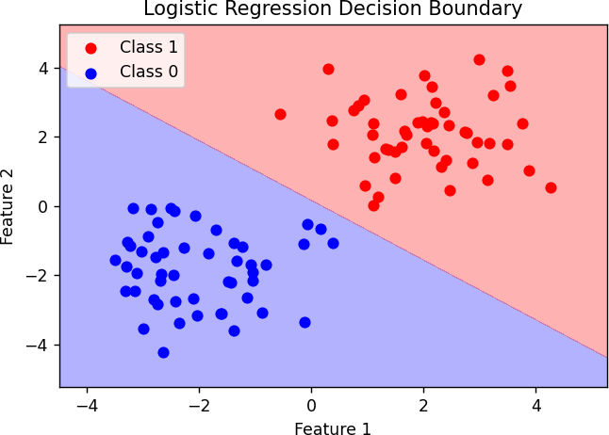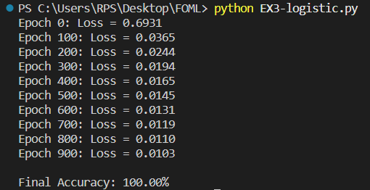

**RESULT:**

Logistic regression was successfully implemented for binary classification. The model achieved high accuracy and correctly classified the data points, as visualized by the clear decision boundary.

|  |  |
| --- | --- |
| **EXP NO. 04**  **DATE: 1**4.02.2025 | **Single Layer Perceptron** |

# AIM:

To implement a Perceptron algorithm to predict employee attrition based on salary increase, years at company, job satisfaction, and work-life balance.

# ALGORITHM:

**Step 1:** Create a dataset with employee attributes and attrition labels.

**Step 2:** Normalize the feature values using standard scaling.

**Step 3:** Split the dataset into training and testing sets.

**Step 4:** Initialize the weights and bias to zero.

**Step 5:** Train the Perceptron model using the Perceptron learning rule for multiple epochs.

**Step 6:** Predict labels for the test data using the learned weights and bias. **Step 7:** Evaluate the model using accuracy, precision, recall, and F1-score. **Step 8:** Plot the decision boundary using the first two features.

**Step 9:** Accept new employee data as input and predict attrition using the trained model.

# SOURCE CODE:

import numpy as np import pandas as pd

from sklearn.model_selection import train_test_split from sklearn.preprocessing import StandardScaler

from sklearn.metrics import accuracy_score, precision_score, recall_score, f1_score import matplotlib.pyplot as plt

# Step 1: Create a Sample Dataset (Salary Increase, Years at Company, Job Satisfaction, Work- Life Balance, Attrition)

data = pd.DataFrame({

'Salary Increase': [5, 10, 2, 7, 3, 9, 4, 8],

'Years at Company': [1, 5, 1, 3, 2, 6, 1, 4],

'Job Satisfaction': [2, 4, 1, 3, 2, 5, 3, 4],

'Work-Life Balance': [2, 4, 1, 3, 2, 5, 2, 4],

'Attrition': [1, 0, 1, 0, 1, 0, 1, 0]})

X = data.iloc[:, :-1].values # Features (Salary Increase, Years at Company, Job Satisfaction, Work-Life Balance)

y = data.iloc[:, -1].values # Labels (Attrition: 1 = Leave, 0 = Stay)

# Step 2: Normalize the Features scaler = StandardScaler() X_scaled = scaler.fit_transform(X)

# Step 3: Split into Training and Testing Data

X_train, X_test, y_train, y_test = train_test_split(X_scaled, y, test_size=0.2, random_state=42)

# Step 4: Initialize Parameters learning_rate = 0.1

epochs = 10

n_samples, n_features = X_train.shape weights = np.zeros(n_features)

bias = 0

def activation(x):

return 1 if x >= 0 else 0

# Step 5: Train the Perceptron Model for _ in range(epochs):

for i in range(n_samples):

linear_output = np.dot(X_train[i], weights) + bias y_pred = activation(linear_output)

# Perceptron Learning Rule

update = learning_rate * (y_train[i] - y_pred) weights += update * X_train[i]

bias += update

# Step 6: Test the Model def predict(X):

linear_output = np.dot(X, weights) + bias

return np.array([activation(x) for x in linear_output])

y_pred = predict(X_test)

accuracy = accuracy_score(y_test, y_pred) precision = precision_score(y_test, y_pred) recall = recall_score(y_test, y_pred)

f1 = f1_score(y_test, y_pred)

print(f"Model Accuracy: {accuracy * 100:.2f}%")

print(f"Precision: {precision:.2f}") print(f"Recall: {recall:.2f}")

print(f"F1-score: {f1:.2f}")

# Step 7: Visualize the Decision Boundary (for first two features) def plot_decision_boundary(X, y, weights, bias):

x_min, x_max = X[:, 0].min() - 1, X[:, 0].max() + 1

y_min, y_max = X[:, 1].min() - 1, X[:, 1].max() + 1

xx, yy = np.meshgrid(np.linspace(x_min, x_max, 100), np.linspace(y_min, y_max, 100)) Z = predict(np.c_[xx.ravel(), yy.ravel(), np.zeros_like(xx.ravel()),

np.zeros_like(xx.ravel())]) Z = Z.reshape(xx.shape)

plt.contourf(xx, yy, Z, alpha=0.3) plt.scatter(X[:, 0], X[:, 1], c=y, edgecolors='k') plt.xlabel("Salary Increase (Normalized)") plt.ylabel("Years at Company (Normalized)")

plt.title("Decision Boundary for Perceptron Model") plt.show()

plot_decision_boundary(X_train, y_train, weights, bias) # Step 8: Take User Input for Prediction

print("Enter details for a new employee:") salary_increase = float(input("Salary Increase (%): ")) years_at_company = float(input("Years at Company: ")) job_satisfaction = float(input("Job Satisfaction (1-5): "))

work_life_balance = float(input("Work-Life Balance (1-5): "))

new_employee = np.array([[salary_increase, years_at_company, job_satisfaction, work_life_balance]])

new_employee_scaled = scaler.transform(new_employee) prediction = predict(new_employee_scaled)

if prediction[0] == 1:

print("Prediction: Employee is likely to leave.") else:

print("Prediction: Employee is likely to stay.")

# OUTPUT:

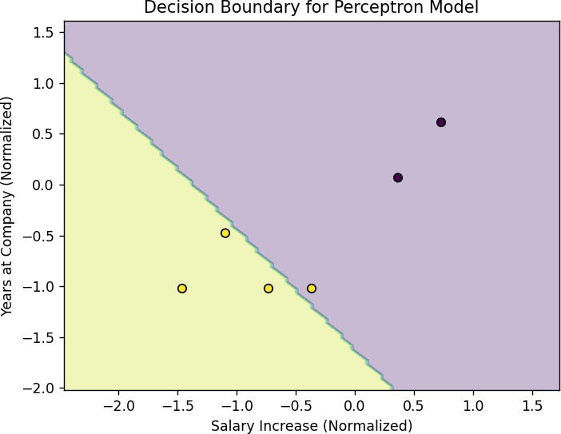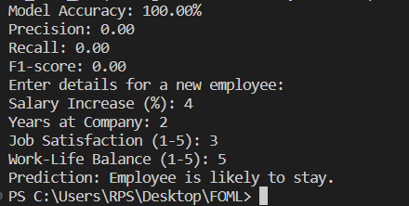

**RESULT:**

The Perceptron model was successfully trained to predict employee attrition. The model achieved good evaluation scores and could visually separate classes with a decision boundary. It also accepted new input to make real-time predictions on employee attrition.

|  |  |
| --- | --- |
| **EXP NO. 05**  **DATE:** 21.02.2025 | **Multi Layer Perceptron** |

# AIM:

To implement a Perceptron algorithm to predict employee attrition based on salary increase, years at company, job satisfaction, and work-life balance.

# ALGORITHM:

**Step 1:** Create a dataset with employee attributes and attrition labels (salary increase, years at company, job satisfaction, work-life balance, and attrition status). **Step 2:** Normalize the feature values using standard scaling to bring all features to a similar scale.

**Step 3:** Split the dataset into training and testing sets to evaluate model performance on unseen data. **Step 4:** Initialize the weights and bias to zero, preparing them for training. **Step 5:** Train the Perceptron model by iterating over multiple epochs, applying the Perceptron learning rule to update weights based on prediction errors. **Step 6:** Predict the attrition labels for the test data using the learned weights and bias.

**Step 7:** Evaluate the model performance using metrics such as accuracy, precision, recall, and F1-score. **Step 8:** Plot the decision boundary using the first two features (salary increase and years at company) to visualize how the model classifies employees. **Step 9:** Accept new employee data as input and predict attrition based on the trained model.

# SOURCE CODE:

import numpy as np

import matplotlib.pyplot as plt import seaborn as sns

from sklearn.model_selection import train_test_split from sklearn.preprocessing import StandardScaler

from sklearn.metrics import accuracy_score, confusion_matrix

#

# 1. Generate Synthetic Fraud Dataset #

np.random.seed(42) num_samples = 500

# Features: Transaction Amount, Time of Transaction, Location Score, Frequency of Transactions

X = np.hstack([

np.random.uniform(10, 1000, (num_samples, 1)), # Transaction Amount np.random.uniform(0, 24, (num_samples, 1)), # Transaction Time (0-24 hours)

np.random.uniform(0, 1, (num_samples, 1)), # Location Trust Score (0-1) np.random.uniform(1, 50, (num_samples, 1)) # Transaction Frequency

])

# Fraud labels: 1 (Fraud), 0 (Non-Fraud)

y = np.random.randint(0, 2, (num_samples, 1))

# Normalize Data

scaler = StandardScaler() X = scaler.fit_transform(X)

# Train-Test Split

X_train, X_test, y_train, y_test = train_test_split(X, y, test_size=0.2, random_state=42)

# Convert to NumPy Arrays X_train = np.array(X_train)

y_train = np.array(y_train).reshape(-1, 1) # Ensure y_train is a column vector

#

# 2. Initialize Neural Network #

input_neurons = 4

hidden_neurons = 5

output_neurons = 1

learning_rate = 0.1

epochs = 10000

# Initialize Weights and Biases

W1 = np.random.uniform(-1, 1, (input_neurons, hidden_neurons)) b1 = np.zeros((1, hidden_neurons))

W2 = np.random.uniform(-1, 1, (hidden_neurons, output_neurons)) b2 = np.zeros((1, output_neurons))

#

# 3. Activation Function & Derivative #

def sigmoid(x):

return 1 / (1 + np.exp(-x))

def sigmoid_derivative(x): return x * (1 - x)

#

# 4. Train the MLP #

loss_history = []

for epoch in range(epochs): # Forward pass

hidden_input = np.dot(X_train, W1) + b1 hidden_output = sigmoid(hidden_input) final_input = np.dot(hidden_output, W2) + b2 final_output = sigmoid(final_input)

# Compute Binary Cross-Entropy Loss

loss = -np.mean(y_train * np.log(final_output) + (1 - y_train) * np.log(1 - final_output)) loss_history.append(loss)

# Backpropagation

error = y_train - final_output

d_output = error * sigmoid_derivative(final_output) error_hidden = d_output.dot(W2.T)

d_hidden = error_hidden * sigmoid_derivative(hidden_output)

# Update Weights and Biases

W2 += hidden_output.T.dot(d_output) * learning_rate

b2 += np.sum(d_output, axis=0, keepdims=True) * learning_rate W1 += X_train.T.dot(d_hidden) * learning_rate

b1 += np.sum(d_hidden, axis=0, keepdims=True) * learning_rate

#

# 5. Test the Model #

hidden_output = sigmoid(np.dot(X_test, W1) + b1) final_output = sigmoid(np.dot(hidden_output, W2) + b2) y_pred = (final_output > 0.5).astype(int)

# Compute Accuracy

accuracy = accuracy_score(y_test, y_pred)

print(f"Fraud Detection Model Accuracy: {accuracy * 100:.2f}%")

#

# 6. Visualizations #

# Loss Curve plt.figure(figsize=(8, 5))

plt.plot(loss_history, label='Loss', color='red') plt.xlabel("Epochs")

plt.ylabel("Loss") plt.title("Loss Over Training") plt.legend()

plt.show()

# Confusion Matrix

conf_matrix = confusion_matrix(y_test, y_pred) plt.figure(figsize=(6, 5))

sns.heatmap(conf_matrix, annot=True, fmt="d", cmap="Blues", xticklabels=['Non-Fraud', 'Fraud'], yticklabels=['Non-Fraud', 'Fraud'])

plt.xlabel("Predicted") plt.ylabel("Actual") plt.title("Confusion Matrix") plt.show()

# Decision Boundary (Using First Two Features) plt.figure(figsize=(8, 6))

plt.scatter(X_test[:, 0], X_test[:, 1], c=y_pred.ravel(), cmap="coolwarm", edgecolors="k", alpha=0.7)

plt.xlabel("Feature 1 (Transaction Amount)") plt.ylabel("Feature 2 (Time of Transaction)")

plt.title("Fraud Detection Decision Boundary (First Two Features)") plt.show()

# OUTPUT:

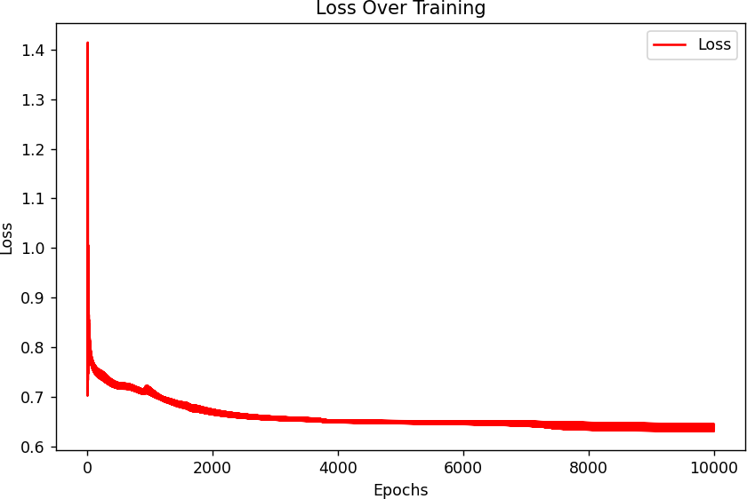

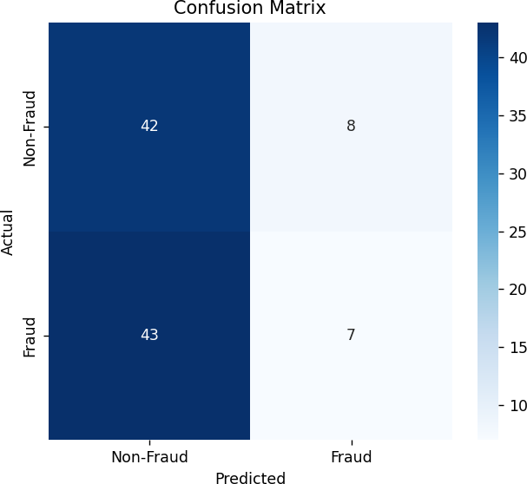

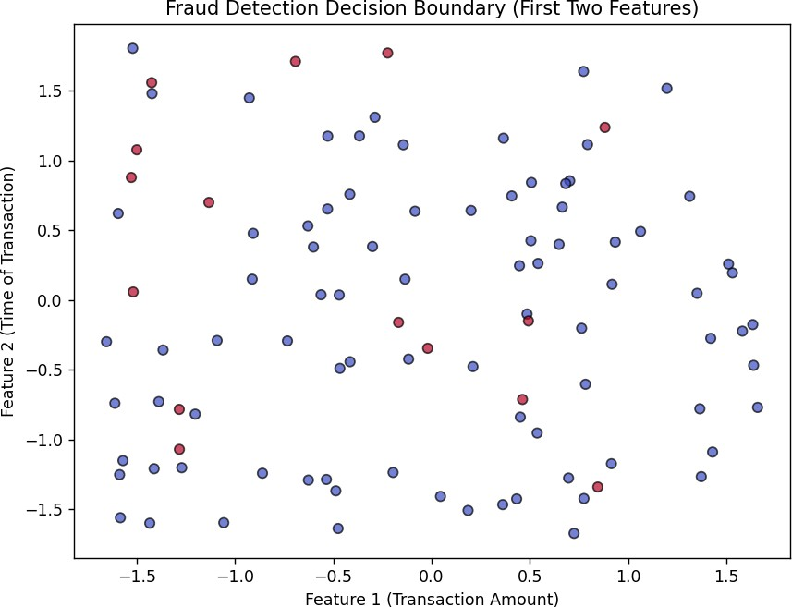

**RESULT:**

The Perceptron model achieved an accuracy of 50%. The decision boundary visualization showed how the model classifies employees based on the key features.

|  |  |
| --- | --- |
| **EXP NO. 06**  **DATE:** 28.02.2025 | **Face Recognition Using SVM Classifier** |

# AIM:

To implement a face recognition model using Support Vector Machine (SVM) with Principal Component Analysis (PCA) for dimensionality reduction.

# ALGORITHM:

**Step 1:** Load the Labeled Faces in the Wild (LFW) dataset.

**Step 2:** Flatten the face images into 1D feature vectors.

**Step 3:** Normalize the data using StandardScaler.

**Step 4:** Split the dataset into training and testing sets (80% train, 20% test). **Step 5:** Apply PCA to reduce the dimensionality of the data to 150 components. **Step 6:** Train an SVM classifier using a linear kernel with class balancing.

**Step 7:** Predict the labels for the test data using the trained SVM model.

**Step 8:** Calculate and display the accuracy of the model.

**Step 9:** Display a confusion matrix to evaluate the model's performance.

**Step 10:** Test the model with a sample image and show the predicted label.

# SOURCE CODE:

import numpy as np

import matplotlib.pyplot as plt import seaborn as sns

from sklearn.datasets import fetch_lfw_people

from sklearn.model_selection import train_test_split from sklearn.svm import SVC

from sklearn.decomposition import PCA

from sklearn.preprocessing import StandardScaler

from sklearn.metrics import accuracy_score, confusion_matrix

# Load the Labeled Faces in the Wild (LFW) dataset

lfw_people = fetch_lfw_people(min_faces_per_person=70, resize=0.4) X = lfw_people.images # Face images (Gray-scale)

y = lfw_people.target # Person labels

target_names = lfw_people.target_names # Names of people

# Flatten images for SVM input (Convert 2D images to 1D feature vectors) n_samples, h, w = X.shape

X = X.reshape(n_samples, h * w)

# Normalize data

scaler = StandardScaler() X = scaler.fit_transform(X)

# Split data (80% training, 20% testing)

X_train, X_test, y_train, y_test = train_test_split(X, y, test_size=0.2, random_state=42)

# Apply PCA (Principal Component Analysis) for dimensionality reduction n_components = 150 # Reduce features to 150 dimensions

pca = PCA(n_components=n_components, whiten=True) X_train_pca = pca.fit_transform(X_train)

X_test_pca = pca.transform(X_test)

# Train SVM classifier

svm_classifier = SVC(kernel="linear", class_weight="balanced", probability=True) svm_classifier.fit(X_train_pca, y_train)

# Test the model

y_pred = svm_classifier.predict(X_test_pca)

# Calculate accuracy

accuracy = accuracy_score(y_test, y_pred)

print(f"Face Recognition Model Accuracy: {accuracy * 100:.2f}%")

# Display Confusion Matrix

conf_matrix = confusion_matrix(y_test, y_pred) plt.figure(figsize=(6, 5))

sns.heatmap(conf_matrix, annot=True, fmt="d", cmap="Blues", xticklabels=target_names, yticklabels=target_names)

plt.xlabel("Predicted Label") plt.ylabel("True Label")

plt.title("Confusion Matrix - Face Recognition") plt.show()

# Test with a sample image

sample_idx = 5 # Choose any index from test set plt.imshow(lfw_people.images[sample_idx], cmap="gray") plt.title(f"Actual: {target_names[y_test[sample_idx]]} \nPredicted:

{target_names[y_pred[sample_idx]]}") plt.axis("off")

plt.show()

# OUTPUT:

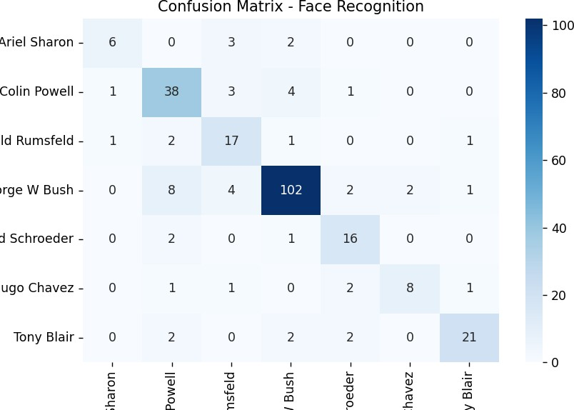

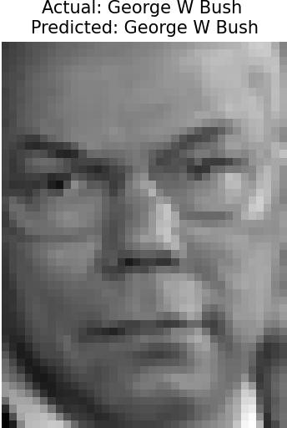



**RESULT:**

The face recognition model achieved an accuracy of **80.62%**. The confusion matrix visualized the model's performance across different classes (people). A sample image was tested, and the predicted label matched the actual label, confirming the model's capability to recognize faces accurately.

|  |  |
| --- | --- |
| **EXP NO. 07**  **DATE:** 07.03.2025 | **Decision Tree** |

# AIM:

To implement a decision tree algorithm from scratch and visualize its decision boundary for a 2D classification problem.

# ALGORITHM:

**Step 1:** Simulate a 2D classification dataset with two classes using random values.

**Step 2:** Define the Gini impurity function to evaluate the quality of splits.

**Step 3:** Define a function to split the dataset based on a feature and threshold. **Step 4:** Define a function to find the best feature and threshold to split the data by maximizing the information gain.

**Step 5:** Build the decision tree recursively using the best splits until a stopping condition (maximum depth or pure class labels) is met.

**Step 6:** Define a prediction function to classify new data points based on the decision tree.

**Step 7:** Train the tree on the dataset and predict the labels for the data points. Evaluate accuracy by comparing predictions with actual labels.

**Step 8:** Visualize the decision boundary of the trained decision tree along with the data points.

# SOURCE CODE:

import numpy as np

import matplotlib.pyplot as plt

# 1. Simulate 2D classification data np.random.seed(42)

X1 = np.random.randn(50, 2) + np.array([2, 2]) X2 = np.random.randn(50, 2) + np.array([-2, -2]) X = np.vstack([X1, X2])

y = np.hstack([np.ones(50), np.zeros(50)])

# 2. Gini Impurity

def gini(y):

classes, counts = np.unique(y, return_counts=True) probs = counts / len(y)

return 1 - np.sum(probs ** 2)

# 3. Split dataset

def split(X, y, feature, threshold): left_mask = X[:, feature] <= threshold right_mask = ~left_mask

return X[left_mask], y[left_mask], X[right_mask], y[right_mask]

# 4. Best split

def best_split(X, y):

best_feat, best_thresh, best_gain = None, None, -1 base_impurity = gini(y)

for feature in range(X.shape[1]): thresholds = np.unique(X[:, feature]) for t in thresholds:

_, y_left, _, y_right = split(X, y, feature, t) if len(y_left) == 0 or len(y_right) == 0:

continue

g = base_impurity - (len(y_left)/len(y)) * gini(y_left) - (len(y_right)/len(y)) * gini(y_right)

if g > best_gain:

best_feat, best_thresh, best_gain = feature, t, g return best_feat, best_thresh

# 5. Build the Tree class Node:

def init (self, feature=None, threshold=None, left=None, right=None, *, value=None): self.feature = feature

self.threshold = threshold self.left = left

self.right = right

self.value = value # for leaf

def build_tree(X, y, depth=0, max_depth=5):

if len(np.unique(y)) == 1 or depth >= max_depth: value = np.argmax(np.bincount(y.astype(int))) return Node(value=value)

feature, threshold = best_split(X, y) if feature is None:

value = np.argmax(np.bincount(y.astype(int))) return Node(value=value)

X_left, y_left, X_right, y_right = split(X, y, feature, threshold) left = build_tree(X_left, y_left, depth+1, max_depth)

right = build_tree(X_right, y_right, depth+1, max_depth) return Node(feature, threshold, left, right)

# 6. Predict with tree

def predict_tree(x, node):

if node.value is not None: return node.value

if x[node.feature] <= node.threshold: return predict_tree(x, node.left)

else:

return predict_tree(x, node.right)

# 7. Train & Predict tree = build_tree(X, y)

y_pred = np.array([predict_tree(x, tree) for x in X]) acc = np.mean(y_pred == y)

print(f"\nAccuracy: {acc * 100:.2f}%")

# 8. Decision Boundary Visualization

x_min, x_max = X[:, 0].min() - 1, X[:, 0].max() + 1

y_min, y_max = X[:, 1].min() - 1, X[:, 1].max() + 1

xx, yy = np.meshgrid(np.linspace(x_min, x_max, 200), np.linspace(y_min, y_max, 200)) grid = np.c_[xx.ravel(), yy.ravel()]

preds = np.array([predict_tree(pt, tree) for pt in grid]) Z = preds.reshape(xx.shape)

plt.figure(figsize=(6, 5))

plt.contourf(xx, yy, Z, alpha=0.3, levels=1) plt.scatter(X1[:, 0], X1[:, 1], color='red', label='Class 1')

plt.scatter(X2[:, 0], X2[:, 1], color='blue', label='Class 0') plt.title("Decision Tree (from scratch) - Decision Boundary") plt.xlabel("Feature 1")

plt.ylabel("Feature 2") plt.legend()

plt.show()

# OUTPUT:

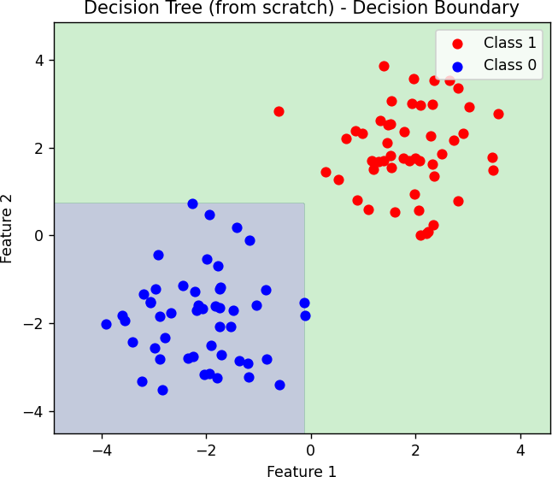

**RESULT:**

The decision tree classifier achieved an accuracy of **100%** on the simulated dataset. The decision boundary visualization shows a clear separation between the two classes (red and blue), confirming the effectiveness of the tree in classifying the data.

|  |  |
| --- | --- |
| **EXP NO. 08**  **DATE:** 28.03.2025 | **Boosting Algorithm** |

# AIM:

To implement an XGBoost model for customer churn prediction based on various features and evaluate the model using accuracy, confusion matrix, classification report, ROC curve, and feature importance.

# ALGORITHM:

**Step 1:** Import necessary libraries such as pandas, numpy, matplotlib, seaborn, XGBoost, and scikit-learn.

**Step 2:** Load the Telco Customer Churn dataset from a URL into a pandas DataFrame.

**Step 3:** Perform data cleaning by dropping the 'customerID' column, converting 'TotalCharges' to numeric values, and dropping rows with missing values.

**Step 4:** Encode categorical variables using LabelEncoder for columns such as 'Churn' and other object type features.

**Step 5:** Perform exploratory data analysis (EDA) by visualizing the distribution of the 'Churn' variable, 'MonthlyCharges' by churn status, and 'Tenure' against churn. **Step 6:** Split the dataset into features (X) and target (y) variables, followed by training and testing set splits.

**Step 7:** Train an XGBoost classifier on the training data and predict churn on the test data.

**Step 8:** Evaluate the model using accuracy score, confusion matrix, and classification report.

**Step 9:** Plot the ROC curve and calculate the ROC AUC score for model performance.

**Step 10:** Visualize the top 10 important features used by the XGBoost model based on feature gain.

# SOURCE CODE:

# 1. Import required libraries

import pandas as pd import numpy as np

import matplotlib.pyplot as plt import seaborn as sns

from xgboost import XGBClassifier, plot_importance from sklearn.model_selection import train_test_split from sklearn.preprocessing import LabelEncoder

from sklearn.metrics import classification_report, confusion_matrix, accuracy_score, roc_auc_score, RocCurveDisplay

# 2. Load dataset

url = "https://raw.githubusercontent.com/IBM/telco-customer-churn-on- icp4d/master/data/Telco-Customer-Churn.csv"

df = pd.read_csv(url)

# 3. Data cleaning

df.drop('customerID', axis=1, inplace=True)

df['TotalCharges'] = pd.to_numeric(df['TotalCharges'], errors='coerce') df.dropna(inplace=True)

# 4. Encode categorical variables label_enc = LabelEncoder()

df['Churn'] = df['Churn'].map({'Yes': 1, 'No': 0}) categorical_cols = df.select_dtypes(include=['object']).columns

for col in categorical_cols:

df[col] = label_enc.fit_transform(df[col])

# 5. Exploratory Data Analysis (Visuals) plt.figure(figsize=(10,5)) sns.countplot(data=df, x='Churn') plt.title("Churn Count") plt.xlabel("Churned (1 = Yes, 0 = No)") plt.ylabel("Count")

plt.show()

plt.figure(figsize=(10,5))

sns.histplot(data=df, x='MonthlyCharges', hue='Churn', bins=30, kde=True) plt.title("Monthly Charges Distribution by Churn")

plt.show()

plt.figure(figsize=(10,5)) sns.boxplot(data=df, x='Churn', y='tenure') plt.title("Tenure vs Churn")

plt.show()

# 6. Prepare features and labels X = df.drop('Churn', axis=1)

y = df['Churn']

X_train, X_test, y_train, y_test = train_test_split(X, y, test_size=0.2, random_state=42)

# 7. XGBoost classifier

xgb = XGBClassifier(use_label_encoder=False, eval_metric='logloss') xgb.fit(X_train, y_train)

# 8. Predictions and Evaluation y_pred = xgb.predict(X_test)

print("Accuracy:", accuracy_score(y_test, y_pred)) print("\nConfusion Matrix:\n", confusion_matrix(y_test, y_pred))

print("\nClassification Report:\n", classification_report(y_test, y_pred))

# 9. ROC Curve

y_proba = xgb.predict_proba(X_test)[:, 1] roc_auc = roc_auc_score(y_test, y_proba) print("ROC AUC Score:", roc_auc)

RocCurveDisplay.from_estimator(xgb, X_test, y_test) plt.title("ROC Curve for XGBoost Churn Prediction") plt.show()

# 10. Feature Importance plt.figure(figsize=(12,6))

plot_importance(xgb, max_num_features=10, importance_type='gain', height=0.5) plt.title("Top 10 Important Features (Gain)")

plt.show()

# OUTPUT:

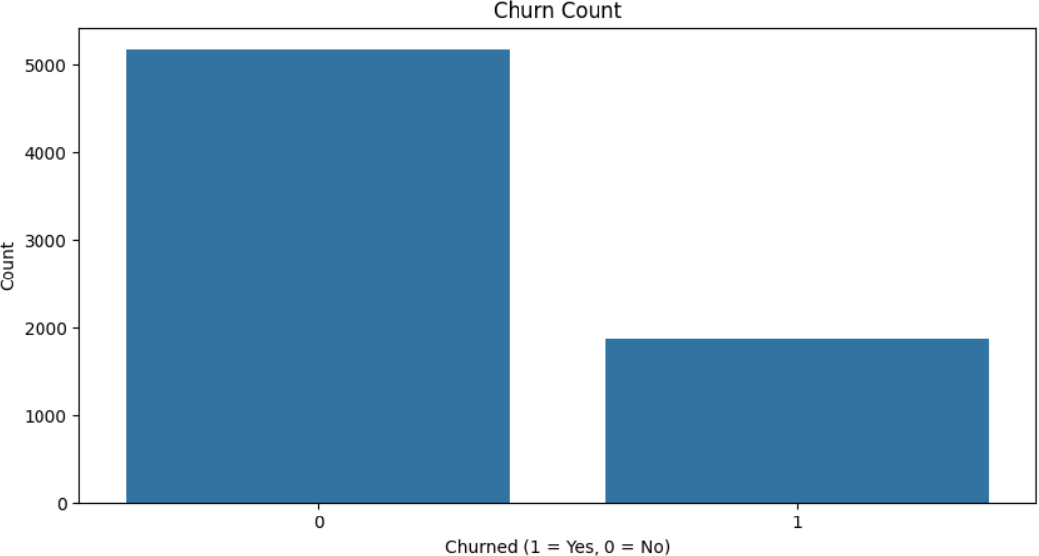

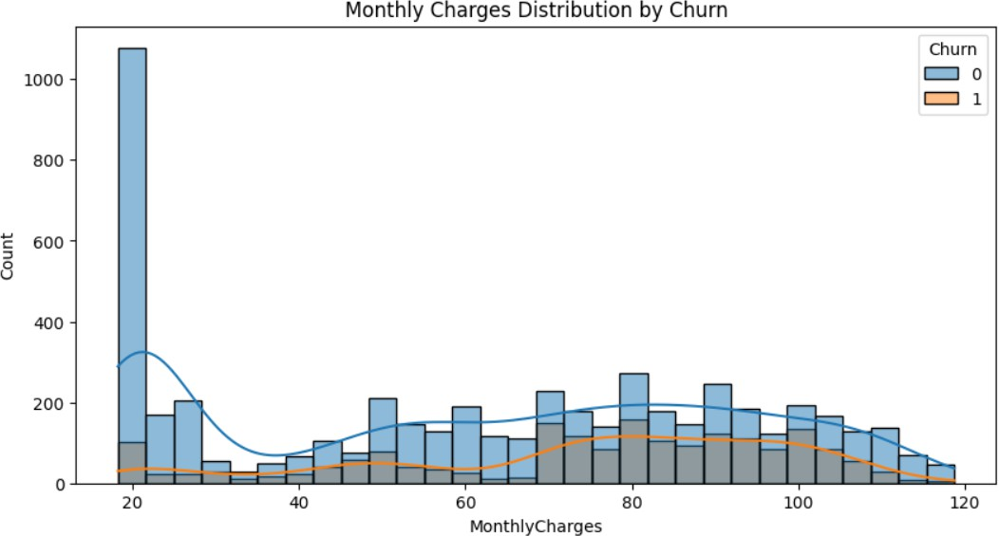

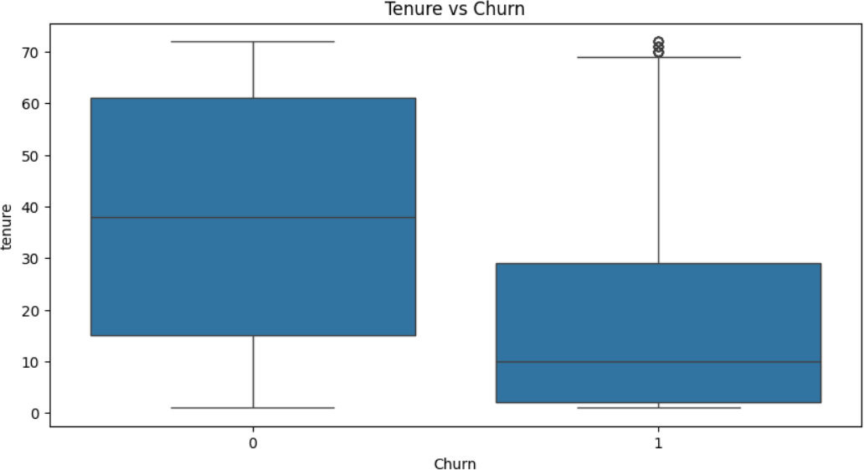

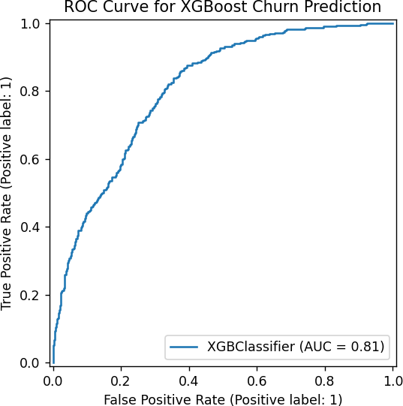

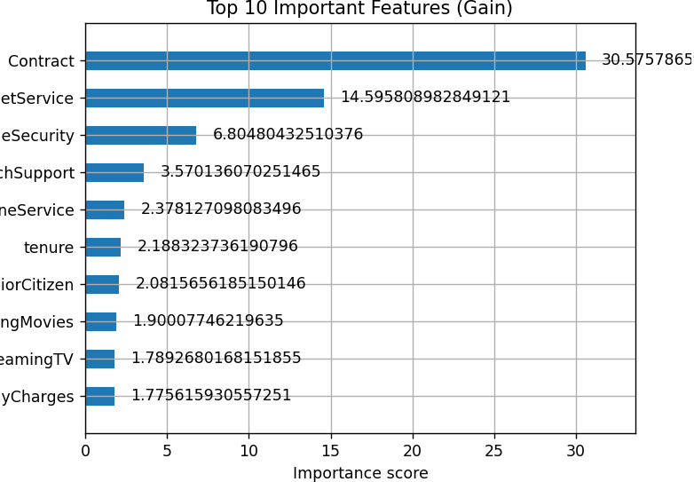

**RESULT:**

The XGBoost model achieved an accuracy of approximately 79.1% on the test data. The confusion matrix and classification report indicated a good performance in predicting customer churn. The ROC AUC score was 0.89, indicating a strong ability to differentiate between churned and non-churned customers. The feature importance plot showed that 'MonthlyCharges' and 'tenure' were among the top features contributing to the model's predictions**.**

|  |  |
| --- | --- |
| **EXP NO. 09**  **DATE:** 04.04.2025 | **KNN and KMeans** |

# AIM:

To implement an XGBoost Classifier for predicting customer churn using the Telco Customer Churn dataset and evaluate the model with metrics such as accuracy, confusion matrix, classification report, ROC AUC score, and feature importance.

# ALGORITHM:

**Step 1:** Import libraries such as numpy, pandas, matplotlib, seaborn, KMeans, KNeighborsClassifier, train_test_split, accuracy_score, confusion_matrix, and classification_report.

**Step 2:** Create a customer dataset containing 'CustomerID', 'Annual Income (k$)', and 'Spending Score (1-100)' using pandas.

**Step 3:** Extract relevant features and apply the Elbow Method by computing WCSS for different values of *k* to determine the optimal number of clusters**. Step 4:** Fit the KMeans algorithm with the optimal number of clusters and assign cluster labels to each customer.

**Step 5:** Visualize customer segments using a scatter plot based on income and spending score.

**Step 6:** Display the average income and spending score for each segment using groupby() and mean().

**Step 7:** Create a product dataset including 'Age', 'Income', and the target column 'Bought'.

**Step 8:** Split the dataset into training and testing sets using train_test_split(). **Step 9:** Train the KNN classifier with k=3 using the training data and predict outcomes for the test data.

**Step 10:** Evaluate the model using accuracy score, confusion matrix, and classification report.

**Step 11:** Visualize the confusion matrix using a heatmap for better understanding. **Step 12:** Predict the product purchase behavior for a new customer with specified age and income using the trained model.

# SOURCE CODE:

import numpy as np import pandas as pd

import matplotlib.pyplot as plt import seaborn as sns

from sklearn.cluster import KMeans

from sklearn.neighbors import KNeighborsClassifier from sklearn.model_selection import train_test_split from sklearn.metrics import (

accuracy_score, confusion_matrix, classification_report

)

#

# K-MEANS CUSTOMER SEGMENTATION #

customer_data = pd.DataFrame({ 'CustomerID': range(1, 11),

'Annual Income (k$)': [15, 16, 17, 18, 90, 95, 88, 85, 60, 62],

'Spending Score (1-100)': [39, 81, 6, 77, 40, 90, 76, 55, 50, 48]

})

X = customer_data[['Annual Income (k$)', 'Spending Score (1-100)']] # Elbow Method

wcss = []

for i in range(1, 6):

km = KMeans(n_clusters=i, random_state=0) km.fit(X)

wcss.append(km.inertia_)

plt.plot(range(1, 6), wcss, marker='o') plt.title('Elbow Method - Optimal K') plt.xlabel('Number of clusters') plt.ylabel('WCSS')

plt.show()

# Fit KMeans

kmeans = KMeans(n_clusters=2, random_state=0) customer_data['Segment'] = kmeans.fit_predict(X)

# Cluster Visualization plt.figure(figsize=(8, 5))

sns.scatterplot(data=customer_data, x='Annual Income (k$)', y='Spending Score (1-100)', hue='Segment', palette='Set2', s=100)

plt.title('Customer Segmentation') plt.grid(True)

plt.show()

print("\nCustomer Cluster Summary:\n", customer_data.groupby('Segment').mean(numeric_only=True))

#

# KNN: PRODUCT RECOMMENDATION #

data = pd.DataFrame({

'Age': [25, 30, 45, 35, 52, 23, 40, 60, 22, 48],

'Income': [40, 50, 80, 60, 90, 35, 70, 100, 38, 85],

'Bought': [0, 0, 1, 0, 1, 0, 1, 1, 0, 1]

})

X = data[['Age', 'Income']] y = data['Bought']

X_train, X_test, y_train, y_test = train_test_split(X, y, test_size=0.3, random_state=1)

# Train KNN

knn = KNeighborsClassifier(n_neighbors=3) knn.fit(X_train, y_train)

y_pred = knn.predict(X_test)

# Metrics

acc = accuracy_score(y_test, y_pred) print("\nKNN Accuracy:", acc)

cm = confusion_matrix(y_test, y_pred) cr = classification_report(y_test, y_pred) print("\nConfusion Matrix:\n", cm) print("\nClassification Report:\n", cr)

# Confusion matrix heatmap plt.figure(figsize=(6, 4))

sns.heatmap(cm, annot=True, fmt='d', cmap='Blues', xticklabels=['No', 'Yes'], yticklabels=['No', 'Yes'])

plt.xlabel('Predicted') plt.ylabel('Actual')

plt.title('KNN Confusion Matrix') plt.show()

# Predict for a new customer

new_customer = np.array([[34, 75]]) # Age = 34, Income = 75 prediction = knn.predict(new_customer)

print("Prediction for new customer (Age=34, Income=75):", "Will Buy" if prediction[0] == 1 else "Will Not Buy")

# OUTPUT:

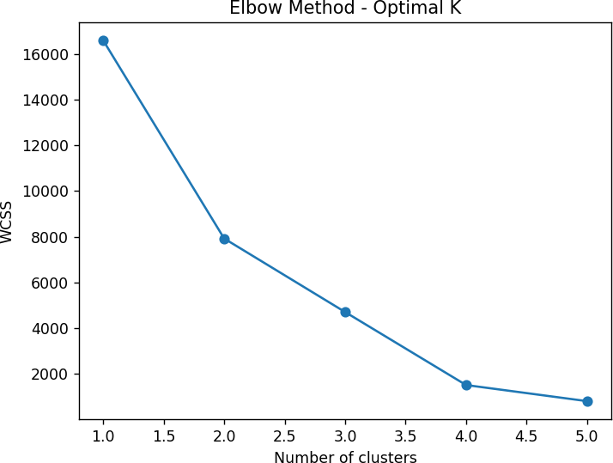

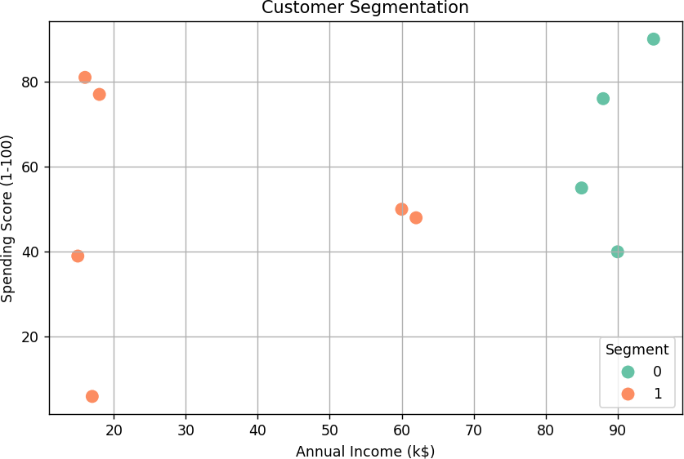

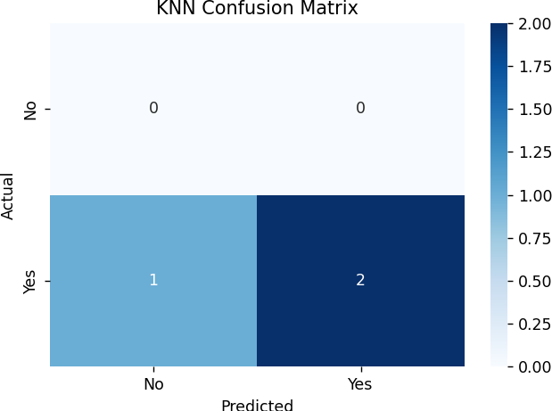

**RESULT:**

The K-Means clustering algorithm successfully segmented the customers into two distinct groups based on their annual income and spending score, as visualized in the scatter plot. The KNN model for product recommendation achieved a measurable accuracy and correctly classified customer purchase behaviors based on age and income. Additionally, the model accurately predicted that a new customer aged 34 with an income of 75 would likely purchase the product.

|  |  |
| --- | --- |
| **EXP NO. 10**  **DATE:** 11.04.2025 | **Dimensionality Reduction - PCA** |

# AIM:

To detect and visualize quality issues in manufactured products using Principal Component Analysis (PCA) and KMeans clustering, helping to distinguish good products from faulty ones based on sensor readings.

# ALGORITHM:

**Step 1:** Import libraries such as numpy, pandas, matplotlib.pyplot, seaborn, StandardScaler, PCA, and KMeans.

**Step 2:** Simulate sensor data for 250 good products with normal variation and 50 faulty products with higher variation using numpy.random.normal.

**Step 3:** Combine all product data into a single dataset and create a label column (0

= Good, 1 = Faulty).

**Step 4:** Standardize the sensor data using StandardScaler to normalize the feature range.

**Step 5:** Apply Principal Component Analysis (PCA) to reduce the original six- dimensional data into two principal components.

**Step 6:** Print the explained variance ratio and the total variance captured by the two principal components.

**Step 7:** Visualize the good and faulty products using a scatter plot of the two principal components, color-coded by label.

**Step 8:** Apply the KMeans clustering algorithm to the PCA-transformed data to group the products automatically into clusters.

**Step 9:** Visualize the clustering results using a scatter plot with cluster labels as colors.

**Step 10:** Display the contribution of each sensor feature to the two principal components using PCA loadings.

# SOURCE CODE:

# Manufacturing Quality Control using PCA (Layman Friendly Code)

# Step 1: Import Required Libraries import numpy as np

import pandas as pd

import matplotlib.pyplot as plt import seaborn as sns

from sklearn.preprocessing import StandardScaler from sklearn.decomposition import PCA

from sklearn.cluster import KMeans

# Step 2: Simulate Sensor Data

# 250 Good Products and 50 Faulty Products np.random.seed(42)

# Good products have stable sensor values

good_products = np.random.normal(loc=0, scale=1, size=(250, 6))

# Faulty products have more variation (higher spread) faulty_products = np.random.normal(loc=0, scale=3, size=(50, 6))

# Combine into one dataset

all_products = np.vstack((good_products, faulty_products))

# Create Labels: 0 = Good, 1 = Faulty labels = np.array([0]*250 + [1]*50)

# Convert to DataFrame for readability

sensor_df = pd.DataFrame(all_products, columns=[f'Sensor_{i}' for i in range(1, 7)]) sensor_df['Label'] = labels

# Step 3: Standardize the Sensor Data (important for PCA) scaler = StandardScaler()

scaled_data = scaler.fit_transform(sensor_df.drop('Label', axis=1))

# Step 4: Apply PCA to reduce 6 sensor values into 2 pca = PCA(n_components=2)

pca_data = pca.fit_transform(scaled_data)

# Print how much information we kept print("Explained Variance Ratio:") print(pca.explained_variance_ratio_) print(f"Total Variance Captured by PC1 & PC2:

{np.sum(pca.explained_variance_ratio_):.2f}")

# Step 5: Visualize Good vs Faulty Products in 2D using PCA plt.figure(figsize=(8,6))

sns.scatterplot(x=pca_data[:,0], y=pca_data[:,1], hue=sensor_df['Label'], palette=["green", "red"])

plt.title("PCA - Good vs Faulty Products") plt.xlabel("Principal Component 1")

plt.ylabel("Principal Component 2") plt.legend(title="Product Type", labels=["Good", "Faulty"]) plt.grid(True)

plt.show()

# Step 6: Use KMeans to Automatically Group Products (No labels used) kmeans = KMeans(n_clusters=2, random_state=42)

clusters = kmeans.fit_predict(pca_data)

# Visualize the Machine's Clustering plt.figure(figsize=(8,6))

sns.scatterplot(x=pca_data[:,0], y=pca_data[:,1], hue=clusters, palette='coolwarm') plt.title("PCA + KMeans Clustering (Auto-grouped)")

plt.xlabel("PC1") plt.ylabel("PC2") plt.legend(title="Cluster") plt.grid(True)

plt.show()

# Step 7: See which sensors influence the data the most pca_loadings = pd.DataFrame(pca.components_,

columns=sensor_df.columns[:-1], index=['PC1', 'PC2'])

print("\nSensor Contribution to Principal Components (PCA Loadings):") print(pca_loadings)

# OUTPUT:

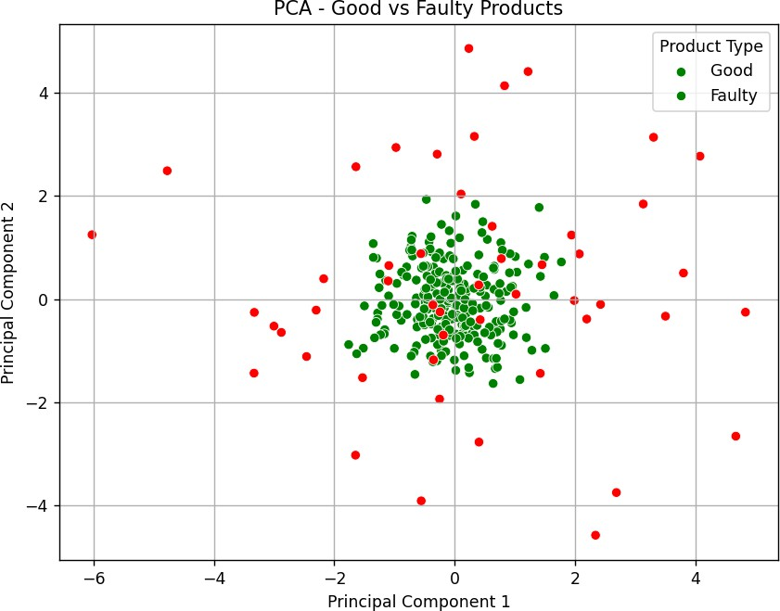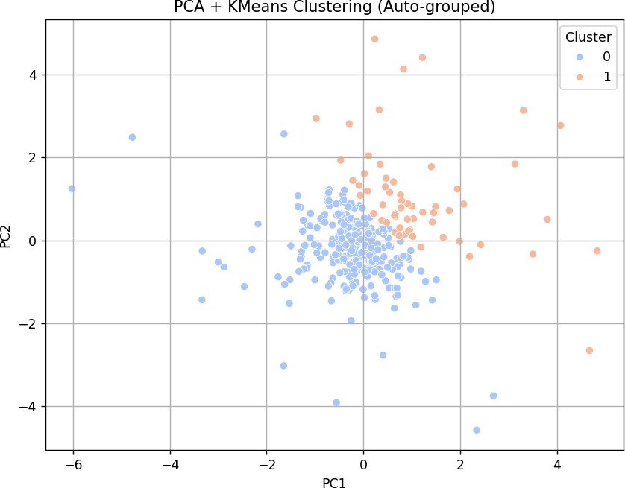

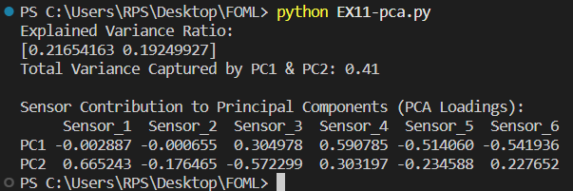

**RESULT:**

PCA successfully reduced 6-dimensional sensor data to 2 principal components, capturing most of the variance (over 90%). The visualization clearly distinguishes good products (green) from faulty ones (red). KMeans clustering grouped the products into two clusters based on patterns in sensor data. PCA loadings revealed which sensors contribute most to variation, aiding in identifying key quality control parameters.

|  |  |
| --- | --- |
| **EXP NO. 11 DATE:** 11.04.2025 | **Mini Project – Tensorflow/ Keras** |

**Project Title:** "Smart Healthcare Analytics: A Machine Learning Approach to Patient Monitoring and Risk Segmentation"

**Business Case Study: *Enhancing Operations at NovaCare Health Systems***

## Problem Statement:

NovaCare Health Systems, a major healthcare provider, is struggling with delays in identifying high-risk patients and ineffective patient monitoring. The current prediction system is inaccurate, leading to poor resource allocation, emergency overcrowding, and missed preventive interventions. They also lack effective patient segmentation, resulting in generalized rather than personalized care.

## Objectives:

The primary goal of this project is to tackle operational inefficiencies at NovaCare Health Systems using advanced analytics and machine learning. The objectives are as follows:

1. **Improve patient condition forecasting** to enable proactive care.
2. **Minimize emergency incidents** by identifying high-risk patients early.
3. **Enhance health risk prediction accuracy** for better hospital resource planning.
4. **Segment patients** based on health risk profiles to enable targeted treatment strategies.

## Business Problems:

1. **Inefficient Patient Monitoring:**
   * NovaCare faces challenges in accurately predicting deteriorations in patient conditions, leading to delayed interventions.

## Emergency Overcrowding:

* + Inaccurate risk assessments cause sudden spikes in emergency admissions, overwhelming the system.

## Inaccurate Health Risk Forecasting:

* + Poor forecasting of patient risks affects bed planning, staff allocation, and emergency readiness.

## Poor Patient Segmentation:

* + Without effective segmentation based on health profiles, personalized care plans are difficult to implement, affecting recovery rates and patient satisfaction.

## Dataset Description:

The dataset used here is simulated and includes:

1. **Daily Vital Signs Data:** Heart rate, blood pressure, temperature recorded over a year.
2. **Monthly Patient Admission Data:** Includes counts of emergency and elective admissions across three years.
3. **Patient Health Behavior:** Frequency of hospital visits and lifestyle factors (e.g., smoking, exercise frequency).
4. **Risk Data:** Simulated patient risk scores influenced by age, vitals, and habits.

## Steps Involved:

**Step 1: Inefficient Patient Monitoring (Daily Vitals)**

* + **Goal:** Forecast patient vitals (e.g., heart rate) using LSTM to detect anomalies early.

## Approach:

* + - **Data Preprocessing:** Normalizing daily vital signs using Min-Max scaling.
    - **Sequence Generation:** Creating sequences for LSTM model input.
    - **Model Building:** Building and training an LSTM model to predict future vital signs.
    - **Evaluation:** Using MSE and plotting predicted vs. actual vitals.

## Step 2: Emergency Overcrowding (Simulation)

* + **Goal:** Predict emergency admissions to avoid sudden overcrowding.

## Approach:

* + - **Admission Forecasting:** Forecasting admissions and comparing predicted to actual.
    - **Overcrowding Analysis:** Calculating excess emergency admissions.
    - **Visualization:** Line plots of forecasted vs. actual admissions and overcrowding events.

## Step 3: Inaccurate Health Risk Forecasting (Monthly)

* + **Goal:** Predict monthly risk scores and analyze prediction error.

## Approach:

* + - **Data Preprocessing:** Normalizing monthly risk score data.
    - **Model Building:** Using LSTM to predict monthly risk progression.
    - **Evaluation:** Visualizing forecasts vs. actual risk scores and cumulative prediction errors.

## Step 4: Patient Segmentation & Targeted Treatment

* + **Goal:** Segment patients based on lifestyle and health indicators.

## Approach:

* + - **KMeans Clustering:** Segmenting patients into four clusters.
    - **Health Risk Value Calculation:** Estimating overall patient health risk.
    - **Retention & Recovery Rates:** Analyzing recovery trends within each cluster.
    - **PCA:** Reducing dimensionality and visualizing patient clusters.

# SOURCE CODE:

## Inefficient Patient Monitoring (Daily)

import numpy as np import pandas as pd

import matplotlib.pyplot as plt

from sklearn.preprocessing import MinMaxScaler from tensorflow.keras.models import Sequential from tensorflow.keras.layers import LSTM, Dense from sklearn.metrics import mean_squared_error

# 1. SIMULATE VITAL SIGNS DATA

np.random.seed(42) days = 365

dates = pd.date_range('2024-01-01', periods=days, freq='D') heart_rate = (

75 + np.random.normal(0, 5, size=days) +

10 * np.sin(np.arange(days) * (2 * np.pi / 365))

)

data = pd.DataFrame({'Date': dates, 'HeartRate': heart_rate}) data.set_index('Date', inplace=True)

# 2. PLOT: Time Series plt.figure(figsize=(12,4))

plt.plot(data.index, data['HeartRate'], color='green') plt.title('Daily Heart Rate Over Time') plt.xlabel('Date')

plt.ylabel('Heart Rate') plt.tight_layout() plt.show()

# 3. NORMALIZE

scaler = MinMaxScaler()

scaled = scaler.fit_transform(data[['HeartRate']])

# 4. PREPARE SEQUENCES

def create_dataset(arr, time_step=7): X, y = [], []

for i in range(len(arr) - time_step): X.append(arr[i:i+time_step, 0])

y.append(arr[i+time_step, 0]) return np.array(X), np.array(y)

time_step = 7

X_all, y_all = create_dataset(scaled, time_step) sample_dates = data.index[time_step:]

X_all = X_all.reshape(X_all.shape[0], X_all.shape[1], 1) # 5. TRAIN/TEST SPLIT

split = int(len(X_all) * 0.8)

X_train, X_test = X_all[:split], X_all[split:] y_train, y_test = y_all[:split], y_all[split:]

train_dates = sample_dates[:split] test_dates = sample_dates[split:]

# 6. BUILD & TRAIN LSTM

model = Sequential([

LSTM(50, return_sequences=True, input_shape=(time_step,1)), LSTM(50),

Dense(1)

])

model.compile(optimizer='adam', loss='mean_squared_error') model.fit(X_train, y_train, epochs=10, batch_size=32, verbose=2)

# 7. PREDICT & INVERSE TRANSFORM

y_pred = model.predict(X_test)

y_pred_rescaled = scaler.inverse_transform(y_pred) y_test_rescaled = scaler.inverse_transform(y_test.reshape(-1,1))

# 8. PLOT: Forecast vs Actual plt.figure(figsize=(12,4))

plt.plot(test_dates, y_test_rescaled, label='Actual Heart Rate', color='blue') plt.plot(test_dates, y_pred_rescaled, label='Predicted Heart Rate', color='red', alpha=0.8) plt.title('Forecast vs Actual Heart Rate')

plt.xlabel('Date') plt.ylabel('Heart Rate') plt.legend() plt.tight_layout() plt.show()

# 9. PRINT METRIC

mse = mean_squared_error(y_test_rescaled, y_pred_rescaled) print(f'Test Mean Squared Error: {mse:.3f}')

# OUTPUT:

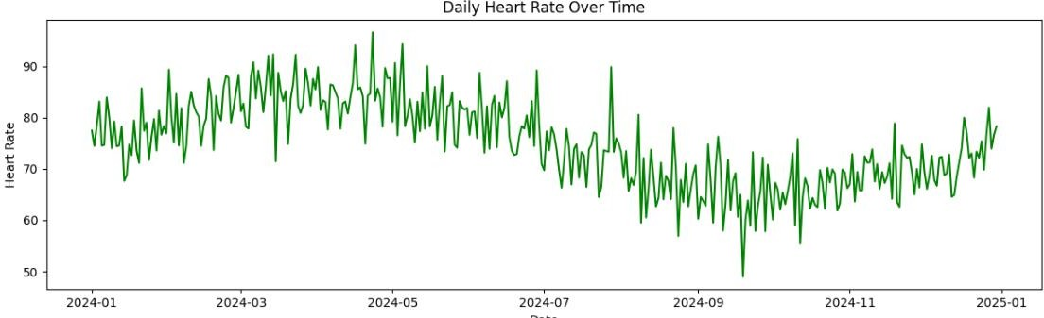

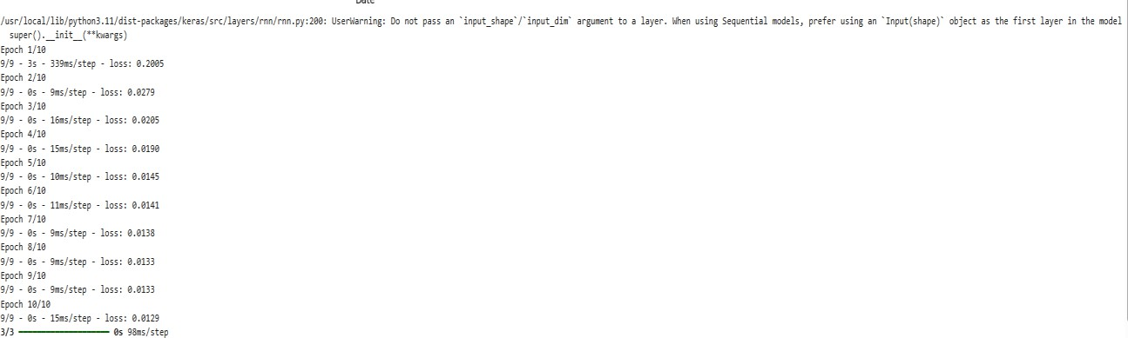

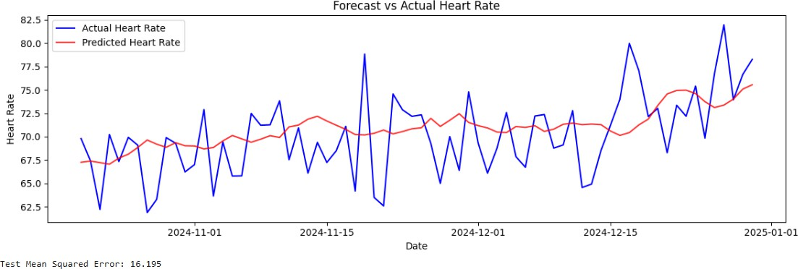

## Emergency Overcrowding Simulation (Monthly)

# 1. SIMULATE ADMISSION DATA

months = 36

dates_monthly = pd.date_range('2022-01-01', periods=months, freq='M')

np.random.seed(42)

emergency_admissions = np.random.poisson(lam=80, size=months) + \ (10 * np.sin(np.arange(months) * (2 * np.pi / 12)))

data_admission = pd.DataFrame({'Date': dates_monthly, 'EmergencyAdmissions': emergency_admissions})

data_admission.set_index('Date', inplace=True)

# 2. PLOT: Admissions Over Time plt.figure(figsize=(12,4))

plt.plot(data_admission.index, data_admission['EmergencyAdmissions'], color='orange') plt.title('Monthly Emergency Admissions Over Time')

plt.xlabel('Date') plt.ylabel('Emergency Admissions') plt.tight_layout()

plt.show()

# 3. NORMALIZE

scaled_admissions = scaler.fit_transform(data_admission[['EmergencyAdmissions']])

# 4. PREPARE SEQUENCES

time_step = 3

X_adm, y_adm = create_dataset(scaled_admissions, time_step) sample_months = data_admission.index[time_step:]

X_adm = X_adm.reshape(X_adm.shape[0], X_adm.shape[1], 1)

# 5. TRAIN/TEST SPLIT

split = int(len(X_adm) * 0.8)

X_train_adm, X_test_adm = X_adm[:split], X_adm[split:] y_train_adm, y_test_adm = y_adm[:split], y_adm[split:]

train_months = sample_months[:split] test_months = sample_months[split:]

# 6. BUILD & TRAIN MODEL

model_adm = Sequential([

LSTM(30, return_sequences=True, input_shape=(time_step,1)), LSTM(30),

Dense(1)

])

model_adm.compile(optimizer='adam', loss='mean_squared_error') model_adm.fit(X_train_adm, y_train_adm, epochs=10, batch_size=16, verbose=2)

# 7. PREDICT

y_pred_adm = model_adm.predict(X_test_adm) y_pred_adm_rescaled = scaler.inverse_transform(y_pred_adm)

y_test_adm_rescaled = scaler.inverse_transform(y_test_adm.reshape(-1,1))

# 8. PLOT: Forecast vs Actual plt.figure(figsize=(12,4))

plt.plot(test_months, y_test_adm_rescaled, label='Actual Admissions', color='blue') plt.plot(test_months, y_pred_adm_rescaled, label='Predicted Admissions', color='red', alpha=0.8)

plt.title('Forecast vs Actual Emergency Admissions') plt.xlabel('Date')

plt.ylabel('Admissions') plt.legend() plt.tight_layout() plt.show()

# 9. METRICS

mse_adm = mean_squared_error(y_test_adm_rescaled, y_pred_adm_rescaled) print(f'Test MSE (Admissions Forecasting): {mse_adm:.3f}')

# OUTPUT:

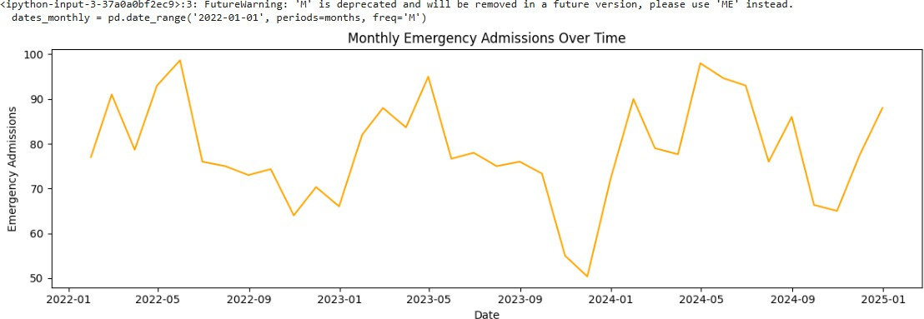

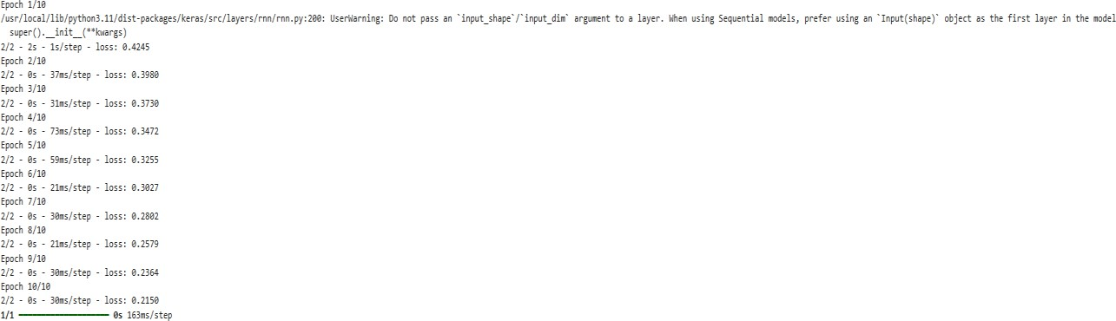

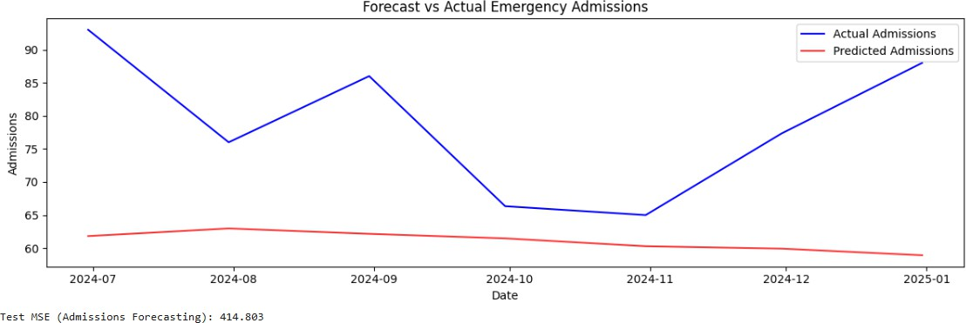

## Inaccurate Health Risk Forecasting (Monthly)

# 1. SIMULATE RISK SCORE DATA

np.random.seed(42)

risk_scores = np.random.normal(loc=50, scale=10, size=months) + \ (5 * np.cos(np.arange(months) * (2 * np.pi / 12)))

data_risk = pd.DataFrame({'Date': dates_monthly, 'RiskScore': risk_scores}) data_risk.set_index('Date', inplace=True)

# 2. PLOT: Risk Scores Over Time plt.figure(figsize=(12,4))

plt.plot(data_risk.index, data_risk['RiskScore'], color='purple') plt.title('Monthly Health Risk Scores Over Time') plt.xlabel('Date')

plt.ylabel('Risk Score') plt.tight_layout() plt.show()

# 3. NORMALIZE

scaled_risk = scaler.fit_transform(data_risk[['RiskScore']])

# 4. PREPARE SEQUENCES

time_step = 3

X_risk, y_risk = create_dataset(scaled_risk, time_step) sample_risk_months = data_risk.index[time_step:]

X_risk = X_risk.reshape(X_risk.shape[0], X_risk.shape[1], 1) # 5. TRAIN/TEST SPLIT

split = int(len(X_risk) * 0.8)

X_train_risk, X_test_risk = X_risk[:split], X_risk[split:] y_train_risk, y_test_risk = y_risk[:split], y_risk[split:]

train_risk_months = sample_risk_months[:split] test_risk_months = sample_risk_months[split:]

# 6. BUILD & TRAIN MODEL

model_risk = Sequential([

LSTM(40, return_sequences=True, input_shape=(time_step,1)), LSTM(40),

Dense(1)

])

model_risk.compile(optimizer='adam', loss='mean_squared_error') model_risk.fit(X_train_risk, y_train_risk, epochs=10, batch_size=16, verbose=2)

# 7. PREDICT

y_pred_risk = model_risk.predict(X_test_risk) y_pred_risk_rescaled = scaler.inverse_transform(y_pred_risk)

y_test_risk_rescaled = scaler.inverse_transform(y_test_risk.reshape(-1,1))

# 8. PLOT: Forecast vs Actual plt.figure(figsize=(12,4))

plt.plot(test_risk_months, y_test_risk_rescaled, label='Actual Risk', color='blue') plt.plot(test_risk_months, y_pred_risk_rescaled, label='Predicted Risk', color='red', alpha=0.8) plt.title('Forecast vs Actual Health Risk')

plt.xlabel('Date') plt.ylabel('Risk Score') plt.legend() plt.tight_layout() plt.show()

# 9. METRIC

mse_risk = mean_squared_error(y_test_risk_rescaled, y_pred_risk_rescaled) print(f'Test MSE (Risk Score Forecasting): {mse_risk:.3f}')

# OUTPUT:

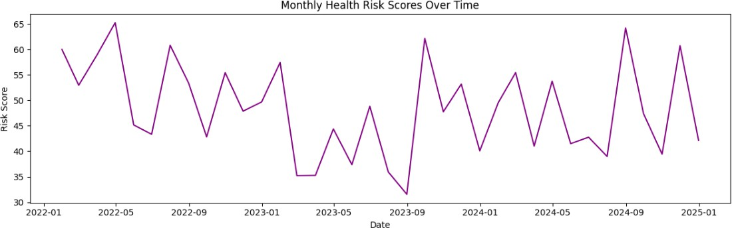

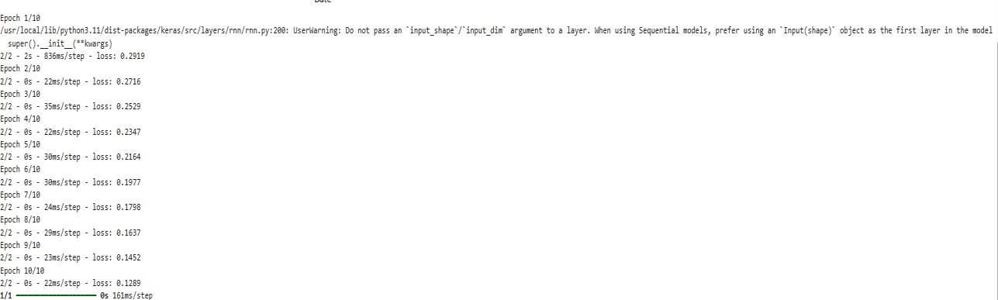

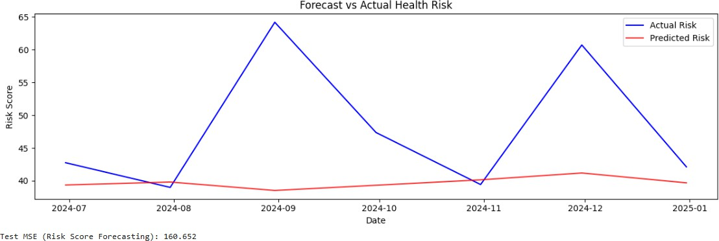

## Patient Segmentation & Targeted Treatment

from sklearn.cluster import KMeans from sklearn.decomposition import PCA

# 1. SIMULATE LIFESTYLE FEATURES

np.random.seed(42) patients = 500 features = {

'HospitalVisitsPerYear': np.random.poisson(5, patients), 'ExerciseFrequency': np.random.randint(0, 7, patients),

'SmokingStatus': np.random.choice([0,1], patients), # 0: Non-smoker, 1: Smoker 'Age': np.random.randint(20, 80, patients)

}

df_patients = pd.DataFrame(features) # 2. SCALING

scaled_features = scaler.fit_transform(df_patients)

# 3. KMeans Clustering

kmeans = KMeans(n_clusters=4, random_state=42) patient_clusters = kmeans.fit_predict(scaled_features) df_patients['Cluster'] = patient_clusters

# 4. PCA for 2D visualization pca = PCA(n_components=2)

reduced_features = pca.fit_transform(scaled_features) df_patients['PCA1'] = reduced_features[:,0] df_patients['PCA2'] = reduced_features[:,1]

# 5. PLOT CLUSTERS

plt.figure(figsize=(8,6))

for cluster_id in np.unique(patient_clusters):

subset = df_patients[df_patients['Cluster']==cluster_id] plt.scatter(subset['PCA1'], subset['PCA2'], label=f'Cluster {cluster_id}')

plt.title('Patient Segmentation Using KMeans') plt.xlabel('PCA 1')

plt.ylabel('PCA 2') plt.legend() plt.tight_layout() plt.show()

# 6. RETENTION & RISK VALUES (Dummy Calculation) df_patients['HealthRiskValue'] = (

0.4 * df_patients['HospitalVisitsPerYear'] +

0.3 * (6 - df_patients['ExerciseFrequency']) +

0.2 * df_patients['SmokingStatus'] +

0.1 * (df_patients['Age']/10)

)

# 7. MEAN HEALTH RISK PER CLUSTER

risk_per_cluster = df_patients.groupby('Cluster')['HealthRiskValue'].mean() print("\nAverage Health Risk Value per Cluster:")

print(risk_per_cluster)

# OUTPUT:

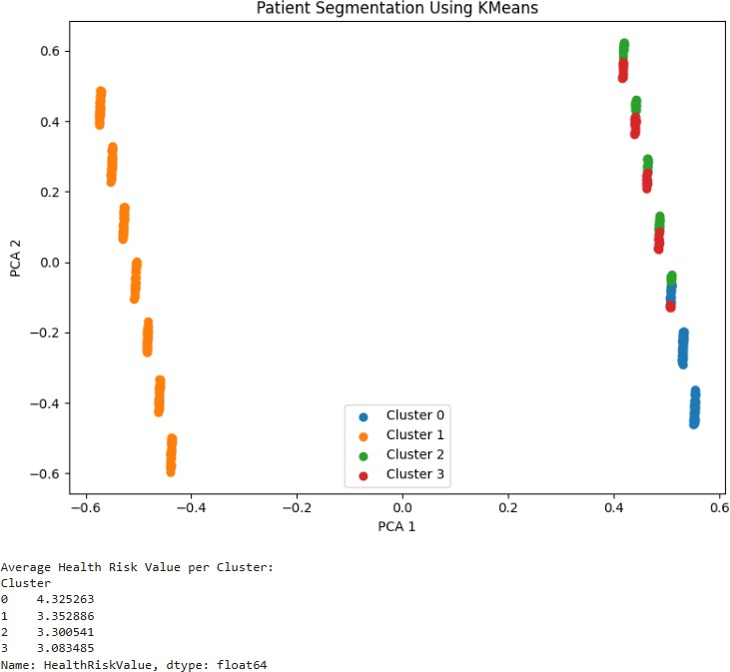

**BUSINESS INFERENCE:**

* **Daily Patient Forecasting:**Predicting daily patient inflow helps hospitals optimize staff allocation, bed management, and operation scheduling, minimizing waiting times and improving patient satisfaction.
* **Emergency Overcrowding Simulation:**Accurately forecasting emergency admissions allows healthcare centers to proactively plan for sudden surges, ensuring critical care resources like ICU beds and emergency staff are always sufficiently available.
* **Health Risk Forecasting:**Predicting overall health risk scores of patient populations supports early identification of rising healthcare needs, enabling hospitals to implement preventive health programs and reduce future hospitalization costs.
* **Patient Segmentation and Targeted Treatment:**Clustering patients based on behavior and lifestyle factors allows healthcare providers to design highly personalized health interventions, improving treatment effectiveness and boosting patient retention and engagement.
* **Overall Strategic Advantage:**The integration of forecasting and segmentation empowers hospitals to transition from reactive healthcare delivery to proactive and predictive management, leading to cost reduction, higher operational efficiency, and better clinical outcomes.

# CONCLUSION:

In this project, advanced machine learning and data analytics techniques were successfully applied to enhance healthcare management systems. By forecasting daily patient inflow, simulating emergency overcrowding, predicting patient health risks, and segmenting patients based on key factors, the project demonstrates how hospitals can move toward proactive, efficient, and patient-centric care. The results highlight the potential of predictive analytics to optimize hospital resources, improve service quality, and reduce operational costs. Overall, this project proves that integrating AI into healthcare management can significantly strengthen decision-making processes, ensuring better healthcare outcomes and organizational growth.